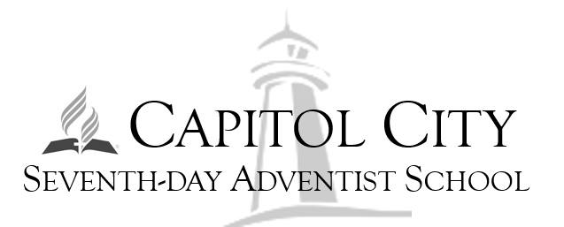
Kindling the Flame to light the Beacons of Tomorrow”
2143 North Boulevard Place  Indianapolis, IN 46202  P. (317)602-3524 F. (317)602-3529  capitolcitysdaschool@gmail.com |  | 2023-2024 School Calendar

* AUGUST
  - 1-Teacher Start Date
  - 7-10 Educator’s Convention
  - 8- WIDA New Students’ Screener
  - 14- First Day of School
  - 17- Open House
  - 25- Spirit Day (Fall Colors)

* SEPTEMBER
* Hispanic Heritage Month (Sept. 15-Oct. 15)
  - 4 - Labor Day (No School)
  - 5 - Grandparents Day
  - 7 - STEAM activity
  - 15- Hispanic Month Chapel
  - 18-29- MAP Testing Window
  - 23- Capitol City SDA Church Visit
  - 27-28- End of Month Assessment/Math & LA

* OCTOBER
*Pastor/Bible Worker Appreciation Month*
  - 6- End of 1st Quarter
  - 9 - Columbus Day (No School)
  - 10-Teacher In-Service (No School)
  - 11 - STEAM activity
  - 12 - Hispanic Celebration
  - 12 - Spirit Day (Ethnic Attire for Hispanic Month Culmination)
  - 18 - Parent Teacher Conference (1:30 P.M. dismissal)
  - 20- Academic Awards Day
  - 21-Tabernacle of Hope SDA Church Visit
  - 24-28- Pastor Appreciation Week
  - 25 -26- End of Term Assessment/Math & LA
  - 28-Tabernacle of Hope SDA Church Visit
  - 30-Launch Warm Blessings Project (Community Service)
  - TBD- Field Trip: Apple Orchard

* NOVEMBER
  - 3- Student Council Candidacy Debate
  - 6- Student Council Election
  - 6-10- Fall Week of Prayer
  - 11-Veterans Day
  - 15- Conference-Wide STEAM Day (Full Day)
  - 17- 21- Fall Week of Prayer
  - 21- Profession Development Day
  - 21- 22 - End of Month Assessment/ Math & LA
  - 23- Thanksgiving Dinner (1:30 P.M. dismissal)
  - 22 - 24-Thanksgiving Break
  - 28- School Resumes

* DECEMBER
  - 2 - School Spirit Day (Red)
  - 8 - School Spelling Bee
  - 12 -Warm Blessings Project Due (Community Service)
  - 13- Christmas Party
  - 14 - Christmas Program
  - 14- Bake Sale (Eight Grade)
  - 15 - End of 2nd quarter
  - 18-1/1 - Christmas Break

* JANUARY
  - 2- School Resumes
  - 4 - Parent/Teacher Conference (1:30 P.M. Dismissal)
  - 5- Spirit Day (Blue)
  - 9- STEAM activity
  - 12 - Academic Awards Day
  - 15- Martin Luther King Jr. Day (No School)
  - 16-26- MAP Testing Window
  - 19- 100th Day of School (PreK-K Activities)
  - 30- Spelling Bee School Wide
  - TBD- Field Trip: Children Museum

* FEBRUARY
*Celebrate Diversity
*Kick off for Preregistration – March!!!
*Kindergarten Round Ups.
* Bring a friend to School.
*Open House Begins
*School Visit
  - 1 - Career Day
  - 14- STEAM activity
  - 16- Spirit Day (Black)
  - 16-16 Professional Development Day (No School)
  - 19-President’s Day (No School)
  - TBD- WIDA Test
  - 21-22- End of Month Assessment- Math & LA
  - 22- Black History Program
  - 24- Maranatha Hispanic SDA Church Visit

* MARCH
  - 8- Literacy Day Across LRC
  - 8- End of 3rd Quarter
  - 15- School Spirit Day (Green)
  - TBD - IREAD3 Test
  - 16- Parent/Teacher Conference (1:30 P.M. Dismissal)
  - 17- Academic Awards Day
  - 20 - 24 - Science Fair
  - 24- Education Day Across the Conference
  - 28 - 29- End of Month Assessment- Math & LA

* APRIL
  - 1-5- Spring Break
  - 8-12- Spring Week of Prayer
  - 17- Bible Fair
  - 19- School Spirit Day (Yellow)
  - 25- STEAM activity

  - TBD- ILEARN Test
  - 24 25- End of Month Assessment- Math & LA
  - 27- Eastside SDA Church Visit

* MAY
  - 6-10 Teachers’ Appreciation Week
  - 6-17- MAPS Testing Window
  - 7- Schools Collaboration Day
  - 20-21 Upper School Trip
  - 23- Volunteer Appreciation Day
  - 24 - Awards Day
  - 27- Memorial Day
  - 30- Graduation at Haughville SDA Church (6:00 P.M.)
  - 31- End of 4th Quarter (Last day of School)
  - TBD- Reaching for Tomorrow- Outdoor Camp

* JUNE
  - 3- Post week meeting
  - 3- Last day of Teachers’ Contract
  - 10- Last day of Principals’ Contract
Total: 181 school days
Fridays 1:20 P.M -1:50 P.M.: READING BUDDIES SESSIONS
School Theme: “Love your neighbor”

